Data 618 Portfolio Management Project

**CUNY SPS MSDS**

**Professor Samuel Gralnick**

**Team Sugar Cane: Euclid Zhang, Jie Zou, Zhenni Xie, Santiago Torres**

**Fall 2022**

Table of Contents

Scenario 2

Assumptions 2

Future Expenses 3

Selection of Stocks 3

Selection of ETFs 5

Final Investment Allocation 6

Appendix 8

A. Painting Contractor Salary 8

B. Schools Expenses 9

C. Mortgage Rates 10

D. Sectors and Industries 11

# Scenario

Using the random number generator from Google, we are assigned scenario number 4.

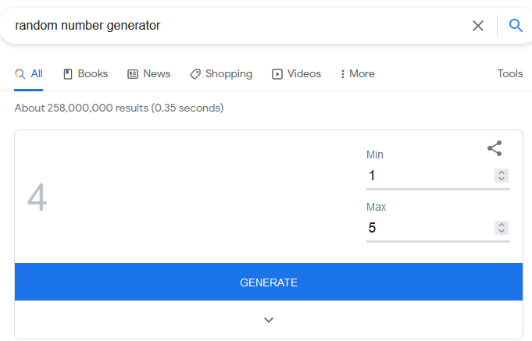

You are a 55-year-old painting contractor. You and your spouse own you home on which there is a mortgage balance of $262,000. Your savings account balance is $6,000 and you have no other investments. You have three children ages 16, 13 and 9. GREAT NEWS; you have just one the state lottery and have opted for a one time cash payout that will amount to $ 125 M.

# Assumptions

Based on the information, we make the following assumptions:

* Assume that I am a risk averse person since I didn’t put any savings in investments.
* As a risk averse person, I would calculate my future expenses conservatively with a 5% inflation rate.
* Assuming I am living in New York, the tax rates for lottery are 25% for the Federal Tax and 8.82% for the State Tax. The after-tax income from the lottery is $82.725 M.
* Based on the salary for painting contractor reported on comparably.com (Appendix A), assume that my annual salary is $100K. This number is a little higher than the average $94K considering that I am a senior painting contractor.
* Assume that my wife has the same age, 55.
* Assume that my wife has similar earning, which is $100K annually.
* For a household income of $200K, the total of after-tax income is $140K.
* My wife and me resign from our jobs immediately.
* Assume that all my children are going to attend college at age 17.
* I would like to guarantee that my children would have enough fund to attend the best schools in the United States. According to the article [10 Most, Least Expensive Private Colleges](https://www.usnews.com/education/best-colleges/the-short-list-college/articles/10-most-least-expensive-private-colleges), the annual cost for the most expensive colleges is about $65K (Appendix B).
* Assume that I bought my house one year before my first child was born, which is 2005. Based on themortgagereports.com, the average 30-year mortgage rate in 2005 is 5.87% (Appendix C).
* Since I had made some savings, assume that my household earning was just enough for the living of my family with a mortgage.
* I would like to guarantee that I can maintain the same or somewhat better lifestyle for the rest of my life. Assume that my wife and me will live up to age 100.

# Future Expenses

With the assumptions, we project that I will have the following expenses in the future:

* $262K mortgage balance.
* Starting $210K (50% increase to the original after-tax income140K for a better lifestyle) per year with 5% increasement per year as cost-of-living adjustment. The total is $35.424M
* $294K starting 1 year after, $341K starting 4 years after, and $414K starting 8 years after for the college expenses for my children. The total is $1049K. The numbers are calculated using the annual expense of $65K per student with a 5% inflation rate.
* Additionally, I would like to reserve $2M for each of my children to cover full or partial expenses of buying their own house or higher education after they finish their undergraduate college degrees.

My total of cash is $82,731,000 ($82,725,000 + $6,000). As a risk averse person, I would like to pay off my mortgage ($262,000) since the interest rate is high as 5.87%. I also keep $210,000 for this year’s living. The remaining balance is $ 82,259,000. The total of expected future expenses (excluding the $210,000 living cost of this year) is $42,263,000.

Putting all the information together, we would put $42,263,000 in risk-free assets such as the U.S. 30 Year Treasury bond. The remaining balance can be invested in equities, hoping to leave a great wealth for my descendants. We will invest $23,997,600 (60% of the remaining $39,996,000) in common stocks and $15,998,400 (40% of the remaining $39,996,000) in ETFs. ETFs are less risky than individual stocks as themselves are diversified portfolios.

Selection of Stocks

To build a diversified portfolio, we would select one stock from each of the sectors categorized on [tradingview](https://www.tradingview.com/markets/stocks-usa/sectorandindustry-sector/), except the Finance sector. We would like to exclude the Finance sector since we are at the risk of a global recession as warned by the [World Bank](https://fortune.com/2022/09/16/world-bank-warns-global-recession-central-banks-raise-rates-in-unison/) and [FedEx CEO, Raj Subramaniam](https://www.cnbc.com/2022/09/15/fedex-ceo-says-he-expects-the-economy-to-enter-a-worldwide-recession.html). When recession turns into crisis, the Finance sector is the first one to fail. We may adjust our portfolio later as we are getting more confident that the recession is coming. Below are the sectors listed on tradingview. For details about the industries in each sector, please see Appendix D.

* COMMERCIAL SERVICES
* COMMUNICATIONS
* CONSUMER DURABLES
* CONSUMER NON-DURABLES
* CONSUMER SERVICES
* DISTRIBUTION SERVICES
* ELECTRONIC TECHNOLOGY
* ENERGY MINERALS
* FINANCE
* HEALTH SERVICES
* HEALTH TECHNOLOGY
* INDUSTRIAL SERVICES
* MISCELLANEOUS
* NON-ENERGY MINERALS
* PROCESS INDUSTRIES
* PRODUCER MANUFACTURING
* RETAIL TRADE
* TECHNOLOGY SERVICES
* TRANSPORTATION
* UTILITIES

Within each sector, we find the common stock with the highest sharpe ratio and PE no greater than 25. The sharpe ratio is calculated using the daily return from 9/17/2021 to 9/16/2022 and the annual yield 3.144% of the U.S. 3 Month Treasury Bill as the risk-free rate. The PE threshold of 25 is used to make sure that overvalued stocks are not selected. We didn’t use the returns before 9/17/2021 since it may be inappropriate to use data during the pandemic to measure the post-pandemic performance.

The selected stocks are:

|  |  |  |  |  |  |
| --- | --- | --- | --- | --- | --- |
| Ticker | Sector | PE | Mean_Return | Volatility | Sharpe_Ratio |
| HSON | COMMERCIAL SERVICES | 11.24 | 0.00392791 | 0.04209888 | 0.09037236 |
| GOGO | COMMUNICATIONS | 6.28 | 0.00106926 | 0.04076846 | 0.02320222 |
| JAKK | CONSUMER DURABLES | 4.11 | 0.00365815 | 0.04901952 | 0.07211032 |
| CALM | CONSUMER NON-DURABLES | 20.99 | 0.00205731 | 0.01941468 | 0.09961384 |
| HRB | CONSUMER SERVICES | 12.99 | 0.00261198 | 0.02432359 | 0.10231403 |
| HDSN | DISTRIBUTION SERVICES | 3.92 | 0.00451732 | 0.05088229 | 0.08635579 |
| BELFA | ELECTRONIC TECHNOLOGY | 11.45 | 0.00313749 | 0.03115059 | 0.09676053 |
| ARLP | ENERGY MINERALS | 10.69 | 0.00408066 | 0.03052002 | 0.12966326 |
| CI | HEALTH SERVICES | 17.11 | 0.00151138 | 0.01648320 | 0.08420955 |
| SRTS | HEALTH TECHNOLOGY | 8.97 | 0.00719350 | 0.05395194 | 0.13104561 |
| LNG | INDUSTRIAL SERVICES | NA | 0.00288781 | 0.02360956 | 0.11709114 |
| BSM | MISCELLANEOUS | 14.22 | 0.00163013 | 0.02146100 | 0.07021069 |
| HUDI | NON-ENERGY MINERALS | NA | 0.01085824 | 0.08137554 | 0.13191808 |
| CF | PROCESS INDUSTRIES | 8.21 | 0.00321401 | 0.02948030 | 0.10483846 |
| CSL | PRODUCER MANUFACTURING | 21.27 | 0.00167321 | 0.01821836 | 0.08507222 |
| MUSA | RETAIL TRADE | 13.04 | 0.00222219 | 0.01998012 | 0.10504722 |
| AZPN | TECHNOLOGY SERVICES | NA | 0.00259436 | 0.02434602 | 0.10149600 |
| ASC | TRANSPORTATION | NA | 0.00498289 | 0.03725396 | 0.13044399 |
| ED | UTILITIES | 21.66 | 0.00122489 | 0.01256987 | 0.08763457 |

We will allocate $23,997,600 evenly in each of above stocks.

# Selection of ETFs

We select 10 ETFs with the highest sharpe ratio. The sharpe ratios are calculated using the same method in the stock selection.

|  |  |  |  |  |
| --- | --- | --- | --- | --- |
| Ticker | Type | Mean_Return | Volatility | Sharpe_Ratio |
| YCS | ETF | 0.00210010 | 0.01190423 | 0.16605530 |
| UUP | ETF | 0.00065341 | 0.00459329 | 0.11540155 |
| EUO | ETF | 0.00132254 | 0.01070854 | 0.11198599 |
| EWV | ETF | 0.00248633 | 0.02292244 | 0.10308659 |
| DIG | ETF | 0.00434383 | 0.04144332 | 0.10183765 |
| TTT | ETF | 0.00356777 | 0.03420061 | 0.10071253 |
| ERX | ETF | 0.00430671 | 0.04205064 | 0.09948424 |
| TMV | ETF | 0.00354277 | 0.03451068 | 0.09908324 |
| TBT | ETF | 0.00238588 | 0.02284666 | 0.09903149 |
| TYO | ETF | 0.00174704 | 0.01658487 | 0.09790240 |

We will allocate $15,998,400 evenly in each of above ETFs.

# Final Investment Allocation

The following is the summary of our investment fund allocation as the assets are purchased using the closing price on 9/16/2022.

|  |  |  |  |  |  |
| --- | --- | --- | --- | --- | --- |
| Ticker | Type | Sector | Price | Units | Amount |
| US30Y | U.S. 30 Year Treasury | NA | $90.44 | 467317.00 | $42,262,981.19 |
| HSON | Common Stock | COMMERCIAL SERVICES | $34.95 | 36138.24 | $1,263,031.49 |
| GOGO | Common Stock | COMMUNICATIONS | $13.32 | 94822.19 | $1,263,031.57 |
| JAKK | Common Stock | CONSUMER DURABLES | $23.37 | 54044.99 | $1,263,031.42 |
| CALM | Common Stock | CONSUMER NON-DURABLES | $56.85 | 22216.91 | $1,263,031.33 |
| HRB | Common Stock | CONSUMER SERVICES | $44.93 | 28111.09 | $1,263,031.27 |
| HDSN | Common Stock | DISTRIBUTION SERVICES | $7.94 | 159071.98 | $1,263,031.52 |
| BELFA | Common Stock | ELECTRONIC TECHNOLOGY | $28.52 | 44285.81 | $1,263,031.30 |
| ARLP | Common Stock | ENERGY MINERALS | $23.88 | 52890.76 | $1,263,031.35 |
| CI | Common Stock | HEALTH SERVICES | $290.35 | 4350.03 | $1,263,031.21 |
| SRTS | Common Stock | HEALTH TECHNOLOGY | $14.80 | 85339.97 | $1,263,031.56 |
| LNG | Common Stock | INDUSTRIAL SERVICES | $167.25 | 7551.75 | $1,263,030.19 |
| BSM | Common Stock | MISCELLANEOUS | $15.70 | 80447.87 | $1,263,031.56 |
| HUDI | Common Stock | NON-ENERGY MINERALS | $29.64 | 42612.40 | $1,263,031.54 |
| CF | Common Stock | PROCESS INDUSTRIES | $98.59 | 12810.95 | $1,263,031.56 |
| CSL | Common Stock | PRODUCER MANUFACTURING | $291.30 | 4335.84 | $1,263,030.19 |
| MUSA | Common Stock | RETAIL TRADE | $276.88 | 4561.65 | $1,263,029.65 |
| AZPN | Common Stock | TECHNOLOGY SERVICES | $226.37 | 5579.50 | $1,263,031.42 |
| ASC | Common Stock | TRANSPORTATION | $10.00 | 126303.15 | $1,263,031.50 |
| ED | Common Stock | UTILITIES | $97.41 | 12966.13 | $1,263,030.72 |
| YCS | ETF | NA | $63.33 | 25261.96 | $1,599,839.93 |
| UUP | ETF | NA | $29.40 | 54416.32 | $1,599,839.81 |
| EUO | ETF | NA | $33.42 | 47870.73 | $1,599,839.80 |
| EWV | ETF | NA | $20.04 | 79832.33 | $1,599,839.89 |
| DIG | ETF | NA | $36.04 | 44390.67 | $1,599,839.75 |
| TTT | ETF | NA | $67.66 | 23645.28 | $1,599,839.64 |
| ERX | ETF | NA | $54.51 | 29349.47 | $1,599,839.61 |
| TMV | ETF | NA | $119.12 | 13430.49 | $1,599,839.97 |
| TBT | ETF | NA | $29.35 | 54509.02 | $1,599,839.74 |
| TYO | ETF | NA | $12.52 | 127782.74 | $1,599,839.90 |

# Appendix

## A. Painting Contractor Salary

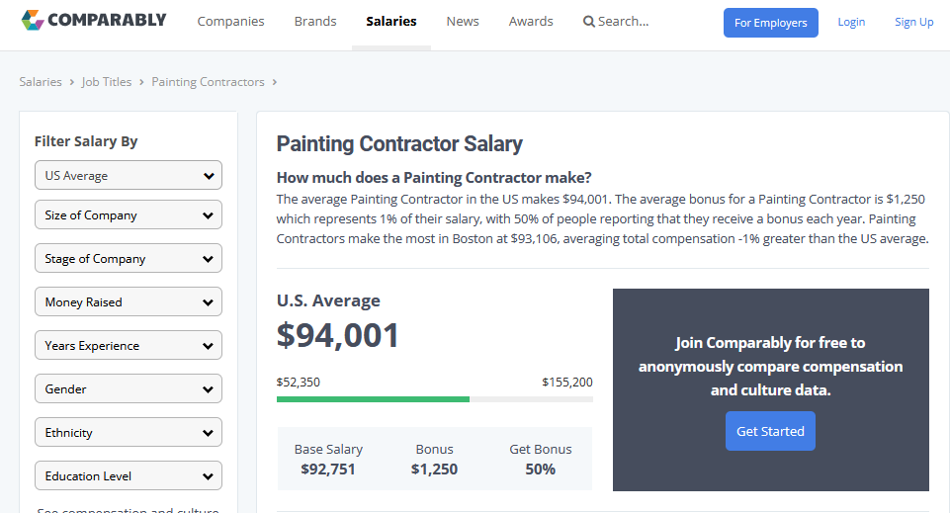

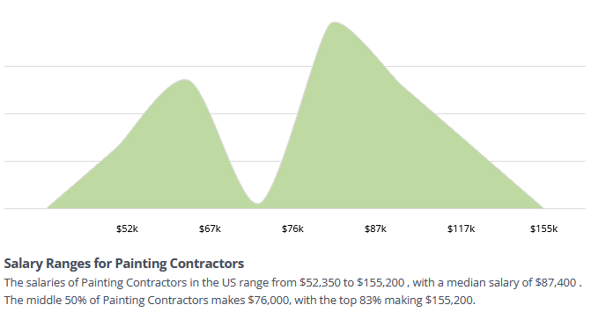

## B. Schools Expenses

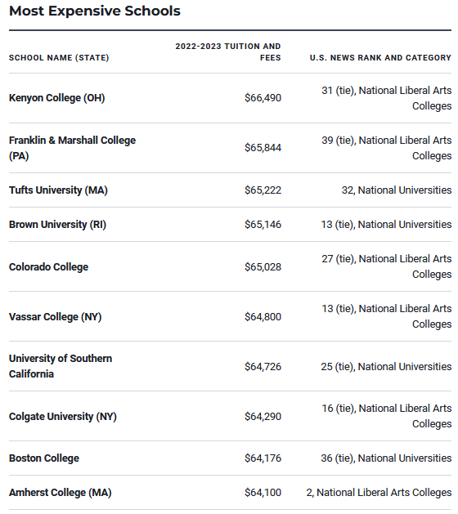

## C. Mortgage Rates

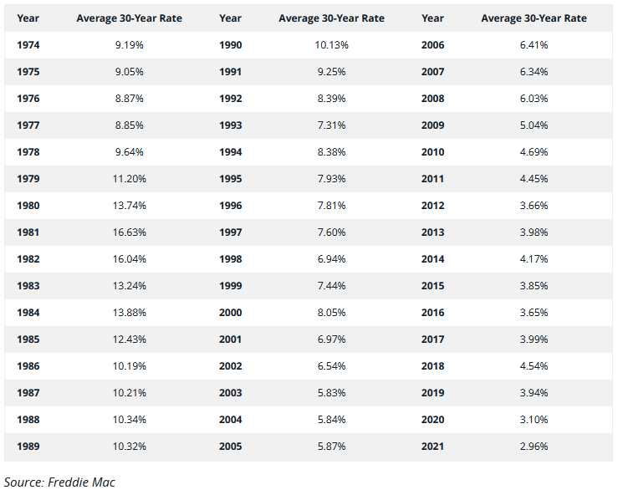

## D. Sectors and Industries

* COMMERCIAL SERVICES
  + Advertising/Marketing Services
  + Commercial Printing/Forms
  + Financial Publishing/Services
  + Miscellaneous Commercial Services
  + Personnel Services
* COMMUNICATIONS
  + Major Telecommunications
  + Specialty Telecommunications
  + Wireless Telecommunications
* CONSUMER DURABLES
  + Automotive Aftermarket
  + Electronics/Appliances
  + Home Furnishings
  + Homebuilding
  + Motor Vehicles
  + Other Consumer Specialties
  + Recreational Products
  + Tools & Hardware
* CONSUMER NON-DURABLES
  + Apparel/Footwear
  + Beverages: Alcoholic
  + Beverages: Non-Alcoholic
  + Consumer Sundries
  + Food: Major Diversified
  + Food: Meat/Fish/Dairy
  + Food: Specialty/Candy
  + Household/Personal Care
  + Tobacco
* CONSUMER SERVICES
  + Broadcasting
  + Cable/Satellite TV
  + Casinos/Gaming
  + Hotels/Resorts/Cruise lines
  + Media Conglomerates
  + Movies/Entertainment
  + Other Consumer Services
  + Publishing: Books/Magazines
  + Publishing: Newspapers
  + Restaurants
* DISTRIBUTION SERVICES
  + Electronics Distributors
  + Food Distributors
  + Medical Distributors
  + Wholesale Distributors
* ELECTRONIC TECHNOLOGY
  + Aerospace & Defense
  + Computer Communications
  + Computer Peripherals
  + Computer Processing Hardware
  + Electronic Components
  + Electronic Equipment/Instruments
  + Electronic Production Equipment
  + Semiconductors
  + Telecommunications Equipment
* ENERGY MINERALS
  + Coal
  + Integrated Oil
  + Oil & Gas Production
  + Oil Refining/Marketing
* FINANCE
  + Finance/Rental/Leasing
  + Financial Conglomerates
  + Insurance Brokers/Services
  + Investment Banks/Brokers
  + Investment Managers
  + Life/Health Insurance
  + Major Banks
  + Multi-Line Insurance
  + Property/Casualty Insurance
  + Real Estate Development
  + Real Estate Investment Trusts
  + Regional Banks
  + Savings Banks
  + Specialty Insurance
* HEALTH SERVICES
  + Hospital/Nursing Management
  + Managed Health Care
  + Medical/Nursing Services
  + Services to the Health Industry
* HEALTH TECHNOLOGY
  + Biotechnology
  + Medical Specialties
  + Pharmaceuticals: Generic
  + Pharmaceuticals: Major
  + Pharmaceuticals: Other
* INDUSTRIAL SERVICES
  + Contract Drilling
  + Engineering & Construction
  + Environmental Services
  + Oil & Gas Pipelines
  + Oilfield Services/Equipment
* MISCELLANEOUS
  + Investment Trusts/Mutual Funds
  + Miscellaneous
* NON-ENERGY MINERALS
  + Aluminum
  + Construction Materials
  + Forest Products
  + Other Metals/Minerals
  + Precious Metals
  + Steel
* PROCESS INDUSTRIES
  + Agricultural Commodities/Milling
  + Chemicals: Agricultural
  + Chemicals: Major Diversified
  + Chemicals: Specialty
  + Containers/Packaging
  + Industrial Specialties
  + Pulp & Paper
  + Textiles
* PRODUCER MANUFACTURING
  + Auto Parts: OEM
  + Building Products
  + Electrical Products
  + Industrial Conglomerates
  + Industrial Machinery
  + Metal Fabrication
  + Miscellaneous Manufacturing
  + Office Equipment/Supplies
  + Trucks/Construction/Farm Machinery
* RETAIL TRADE
  + Apparel/Footwear Retail
  + Catalog/Specialty Distribution
  + Department Stores
  + Discount Stores
  + Drugstore Chains
  + Electronics/Appliance Stores
  + Food Retail
  + Home Improvement Chains
  + Internet Retail
  + Specialty Stores
* TECHNOLOGY SERVICES
  + Data Processing Services
  + Information Technology Services
  + Internet Software/Services
  + Packaged Software
* TRANSPORTATION
  + Air Freight/Couriers
  + Airlines
  + Marine Shipping
  + Other Transportation
  + Railroads
  + Trucking
* UTILITIES
  + Alternative Power Generation
  + Electric Utilities
  + Gas Distributors
  + Water Utilities